The main change in the creative brief was to the milestones that were set in the timeline. We set the dates without accounting for the error we had with setting up and connecting to the database as well as setting up our environment. For these reasons, the MVP and testing were pushed back a couple weeks.

Creative Brief Template

Contents

Background

Audience

Positioning

Corporate Branding and Creative Stretch

Timeline

Budget and Resources

Creative Pitch

Mood Boards

# Background

The Learning Paths by ShowbizU provide people from all backgrounds and lifestyles the opportunity to advance their learning in the arts. The design presented will give users an easy to use system to expose them to storytelling and customize their way of learning by choosing what they want to learn. ShowbizU strives to give people the best opportunity to gain knowledge on specific subjects with a large community of luminaries and tools to do so. ShowbizU is constantly evolving to implement the best, state-of-the-art technology.

# Audience

The Learning Paths targets any users who strive to advance their learning of the arts. Whether they have prior knowledge to the subjects or if they are completely new, ShowbizU’s Learning Paths will give users the tools to accomplish their goals. The audience this application aims to target is broad and robust. People from all lifestyles and backgrounds will be attracted to this application because it allows them to study what they want at their own pace.

# Positioning

The product, the learning paths in particular, will stand for education that caters to any and all students' learning styles. We want users to view the product as the "Google" or "Netflix" of show business. Resources concerning show business already exist, but our tool aims to serve as a centralized hub to find and present the best learning content out of the sea of information on the internet. Our design will convey that users are free to choose the what, when, and how of learning about show business without attending specialized schools.

# Corporate Branding and Creative Stretch

Corporate branding must match the ShowbizU branding, and minimal changes shall be made in the branding.

# Timeline

What are the major milestones for the design? When do you expect to meet the milestones? The following table identifies typical major milestones for a creative brief. Remember to include approval and sign-off milestones in the timeline.

|  |  |
| --- | --- |
| MILESTONE | DATE |
| Project Charter | 10/17/2014 |
| Project Plan | 10/17/2014 |
| Requirements Document/ Use Cases | 10/24/2014 |
| 1st Wireframe Mockups | 10/28/2014 |
| Design Document | 10/31/2014 |
| Preliminary Design | 11/7/2014 |
| Development | 11/21/2014 |
| Test Plan | 11/21/2014 |
| MVP | 11/28/2014 |
| Testing | 12/5/2014 |
| MILESTONE | **DATE** |
| Project Charter | 10/17/2014 |

# Budget and Resources

For now, we prefer to use tools that are available for free. But for our wireframing tool we decided to seek out better applications than those that were available for free. We may use Mockflow, which costs a monthly fee. Other than that, we will use coding environments and other tools that do not cost money.

# Creative Pitch

**Design 1**

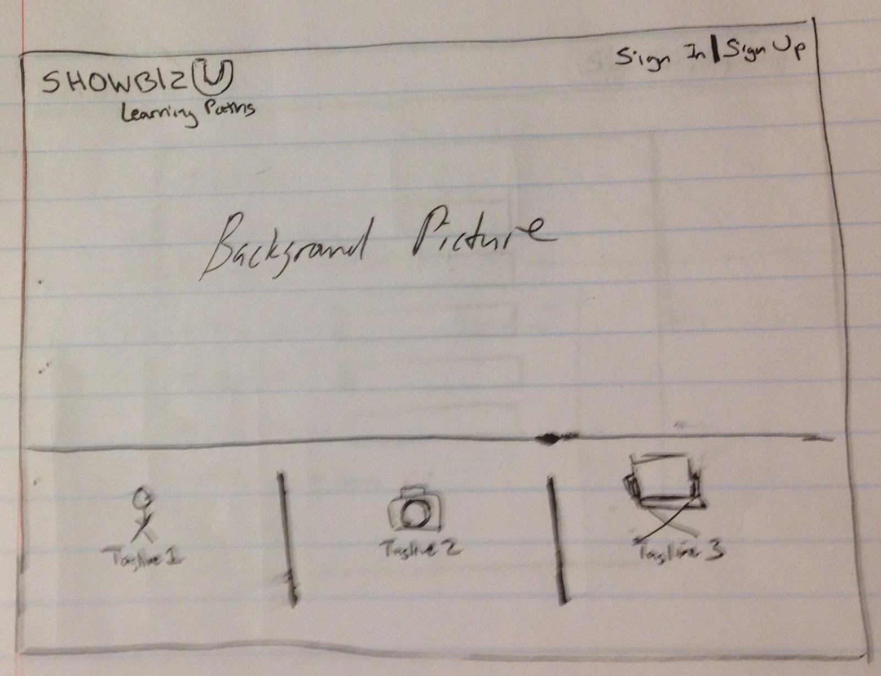

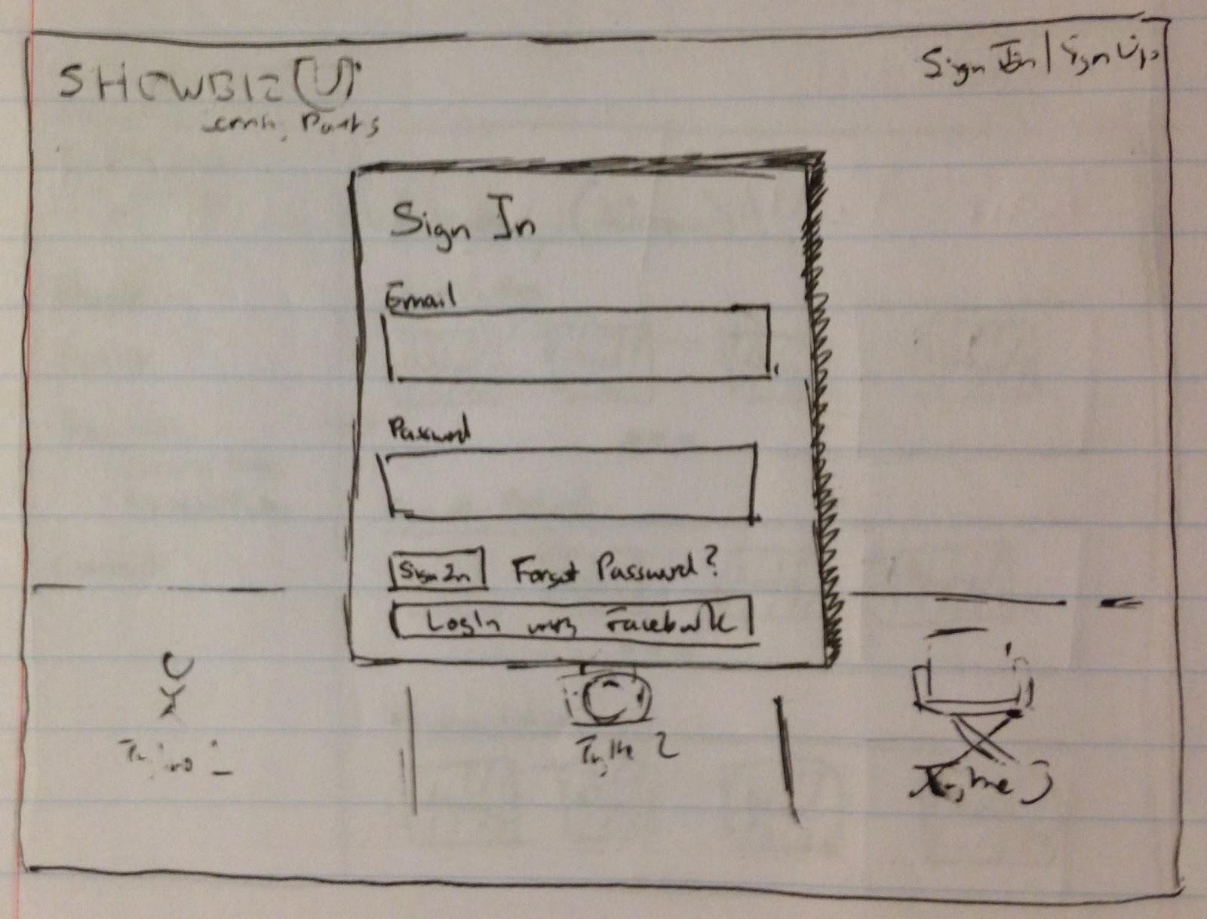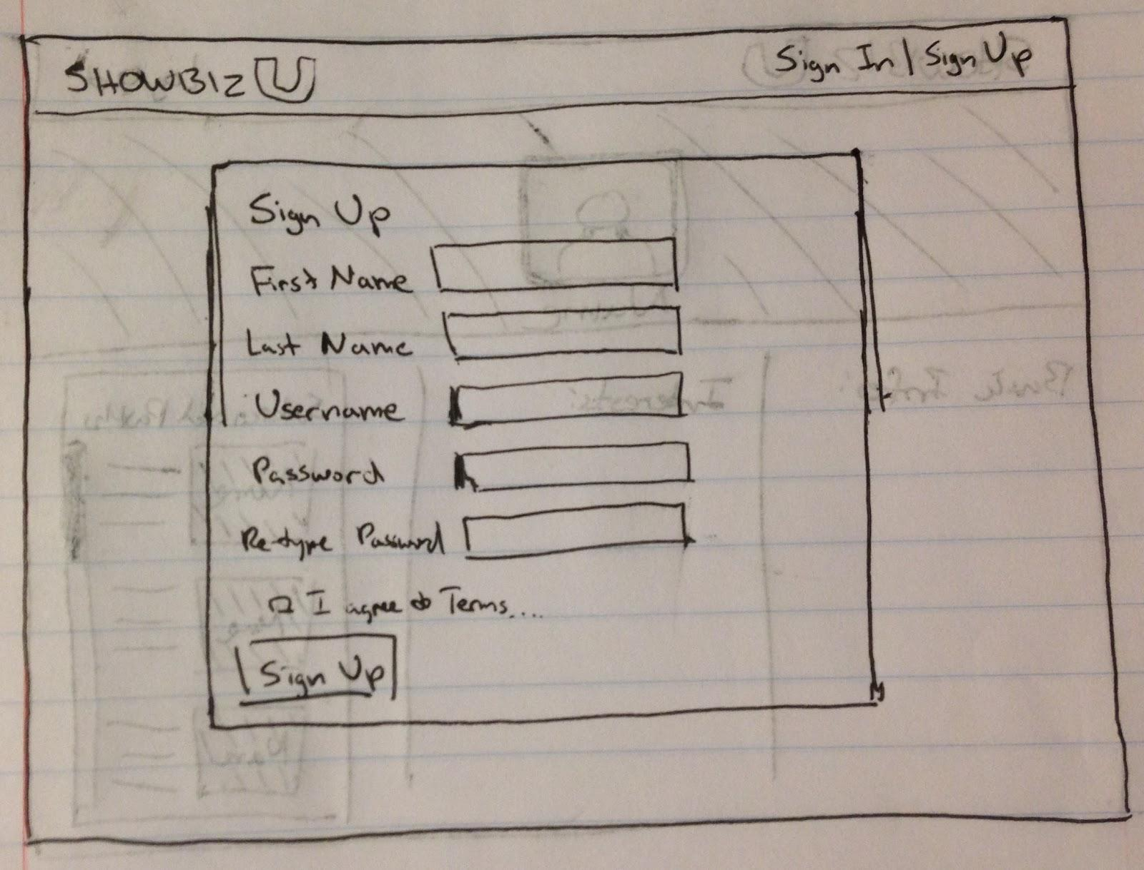

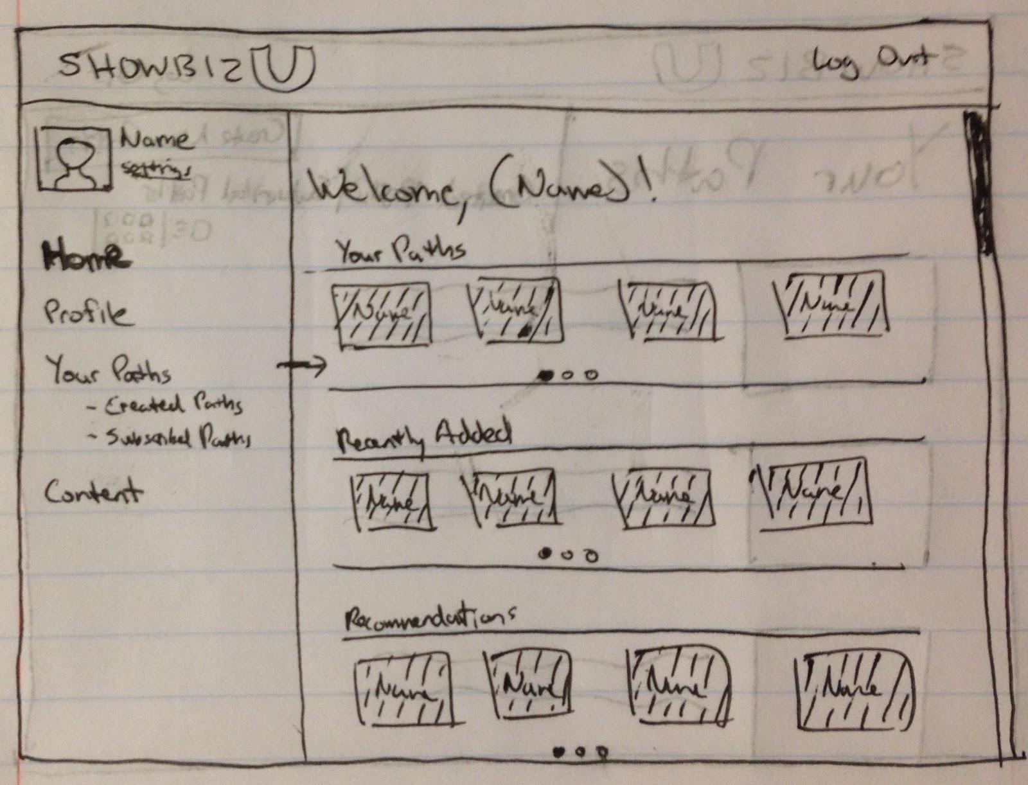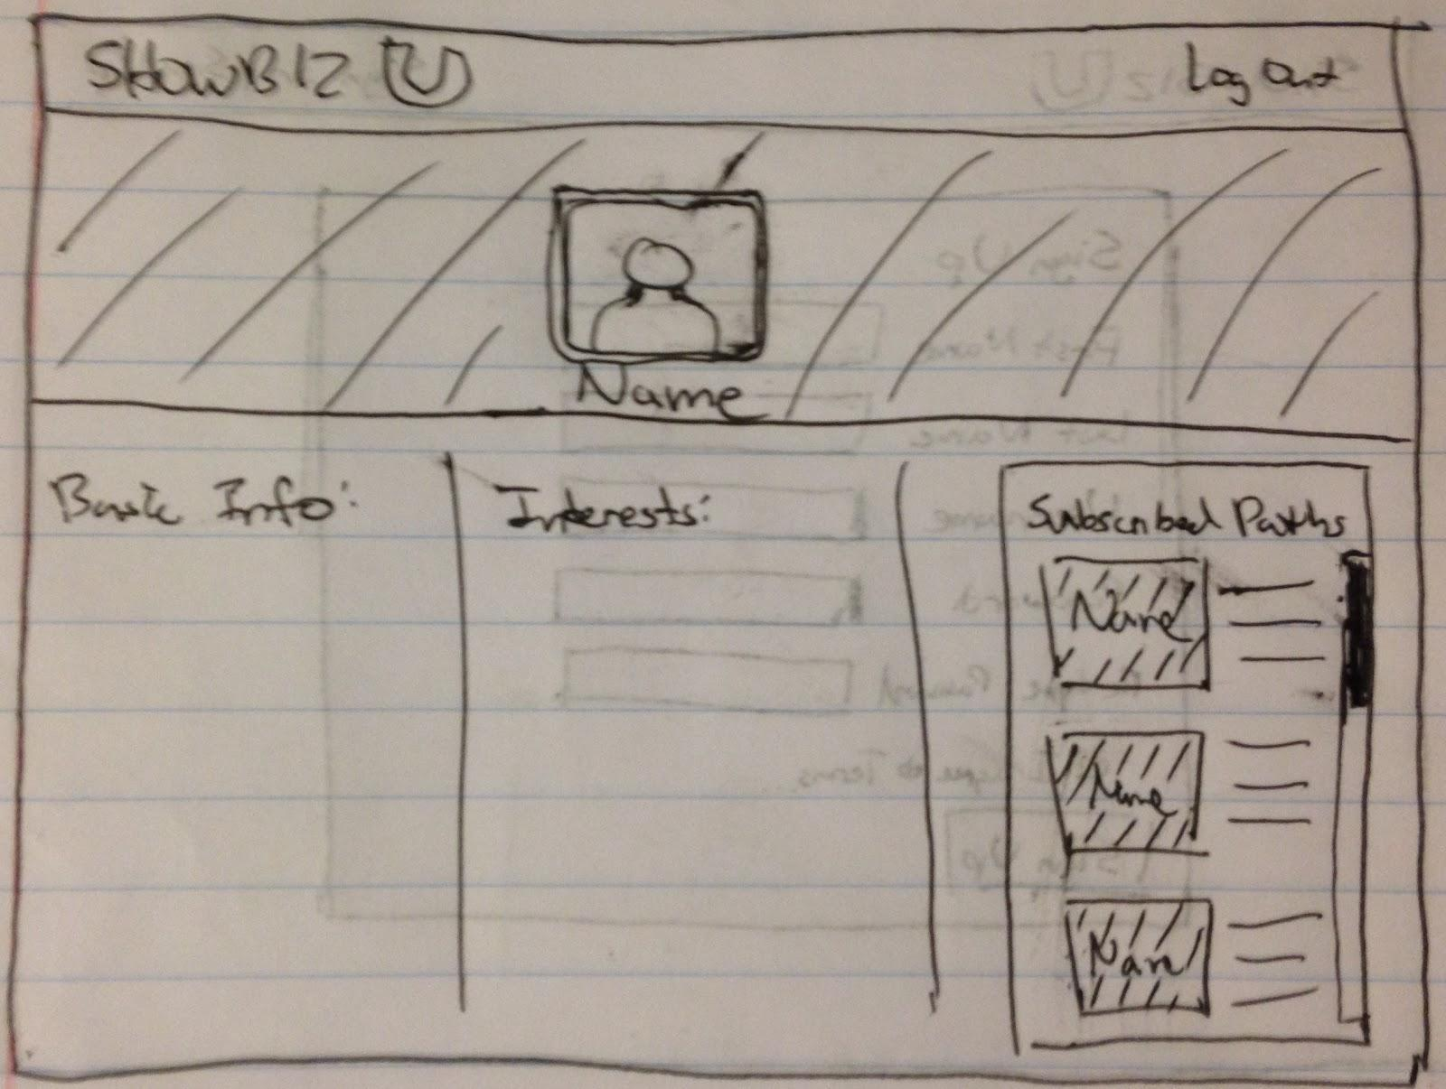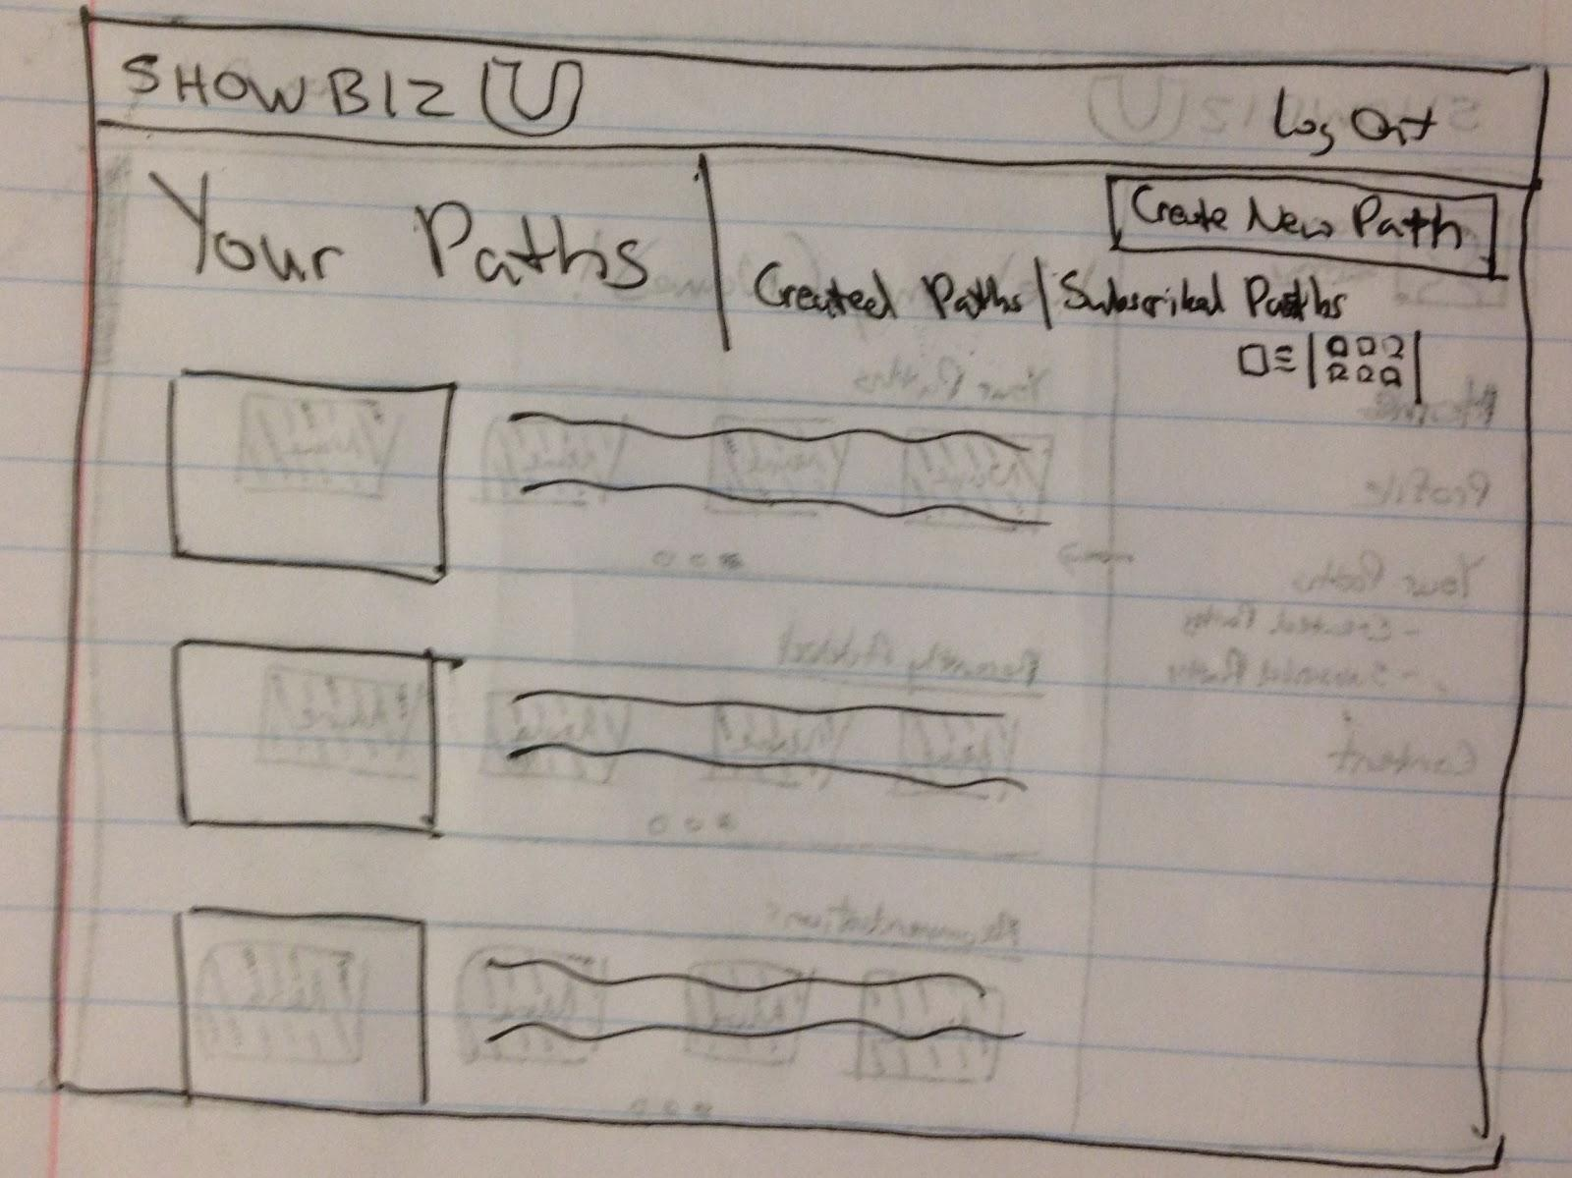

These mockups show the main public homepage of the Learning Paths website and the signed-in pages with all the different views. The homepage is simple and clean, with a background image that represents the Learning Paths, as well as 3 short descriptions divided neatly in thirds on the bottom. The Sign Up/Sign In links are at the top right. The sign-in page is a modified pop-up window within the homepage. There will be a border around the pop-up, and the background will be blurred to create separation. Users are able to do a standard email/password sign-in, as well as Facebook sign-in. The sign-up page brings the user to a different view with the required fields included in a large rectangle in the center of the view. Behind the large rectangle will be a background picture. The homepage after a user signs in introduces a new layout. Similar to Netflix, it shows horizontal sections, with the ability to scroll sideways. Content will be separated by Your Paths, Recently Added, and Recommendations. Your Paths contains only learning paths, obviously. Recently Added and Recommendations sections include both paths and content. They shall be differentiated by different colors. Another key feature of the signed-in view is the hidden sidebar, which becomes visible when the user hovers the mouse over left border of the view. The sidebar provides links to Home, Profile, Your Paths, and Content. The sidebar will highlight the current page that the user is on. It will apply to all signed-in pages. The Profile page shows a picture of the user and a horizontal picture, much like the “Cover Photo” of Facebook. The rest of the profile is divided into 3 sections: basic info, interests, and subscribed paths. Users can scroll through each section individually. In the Your Paths view, users view all their paths in a vertical list, with the path picture and short description. This is the default view. Users can also switch to a block view, which simply shows each path as a picture. This is done by selecting the icon near the top right. Users can filter between their Created Paths and Subscribed Paths by selecting the links next to the Your Paths title. And finally, the Log Out link is visible on all signed-in views at the top right corner.

**Design 2**

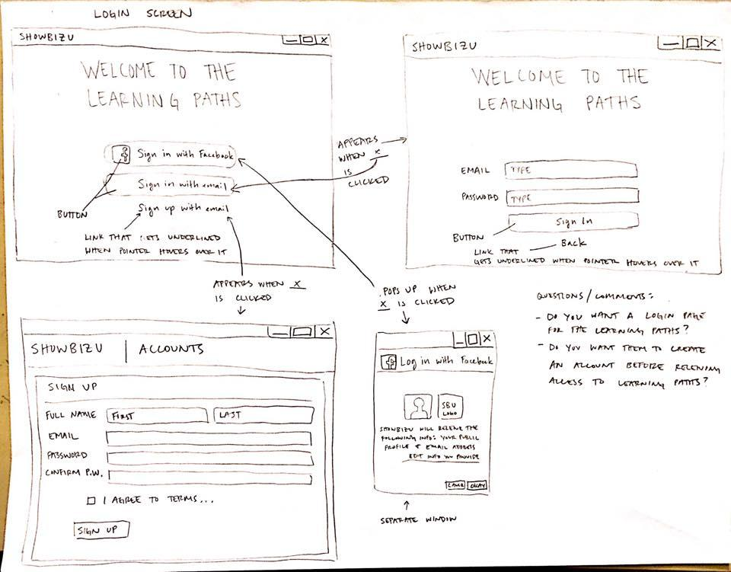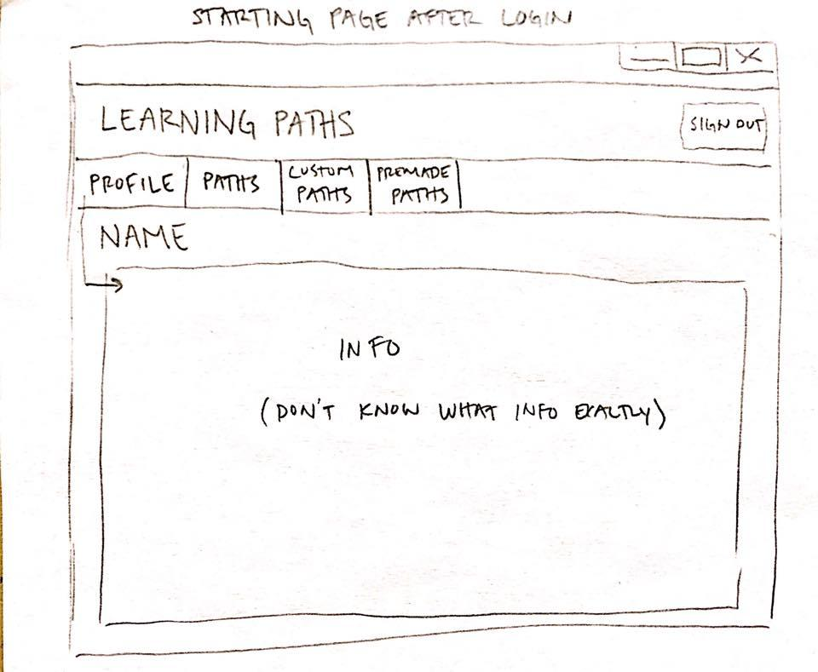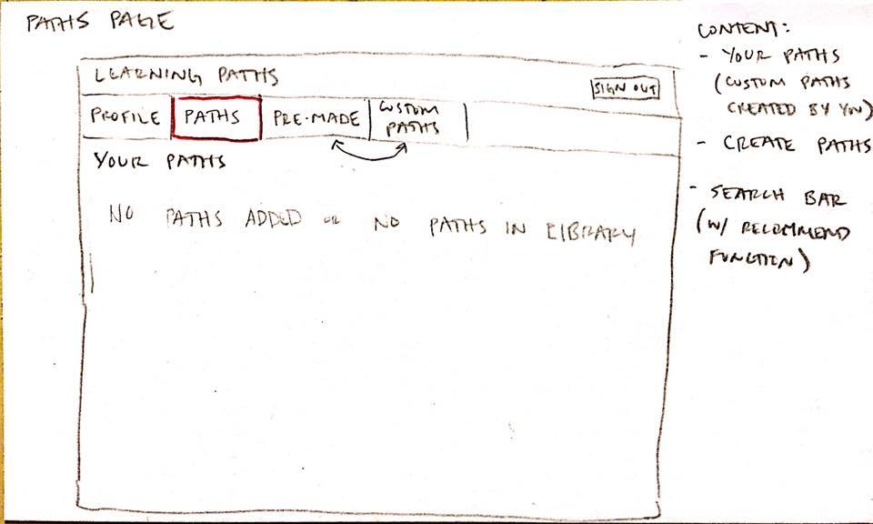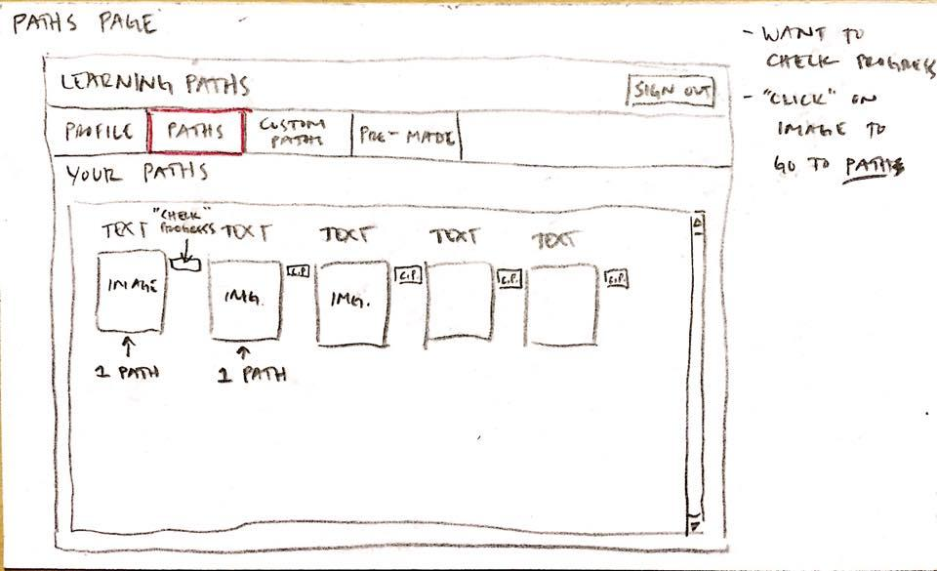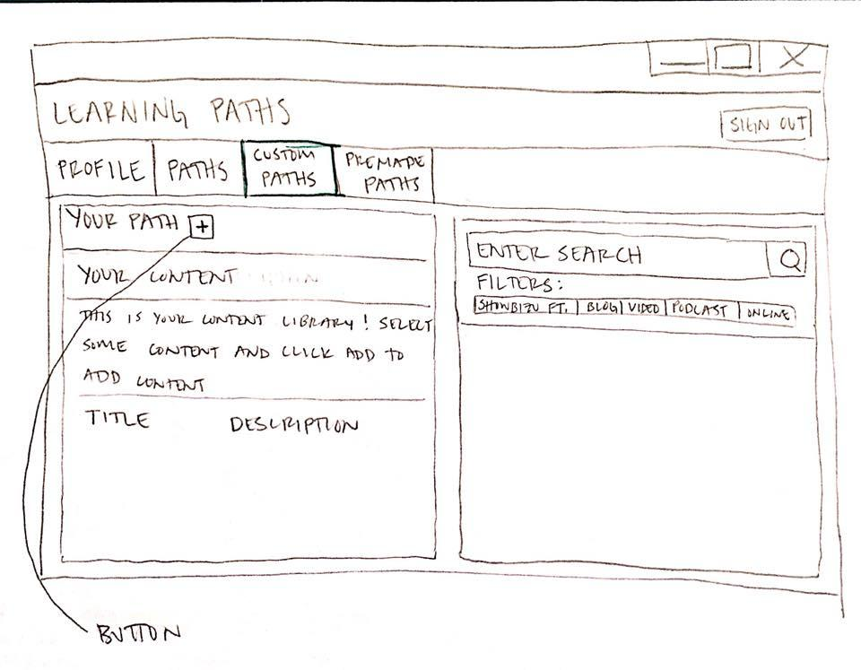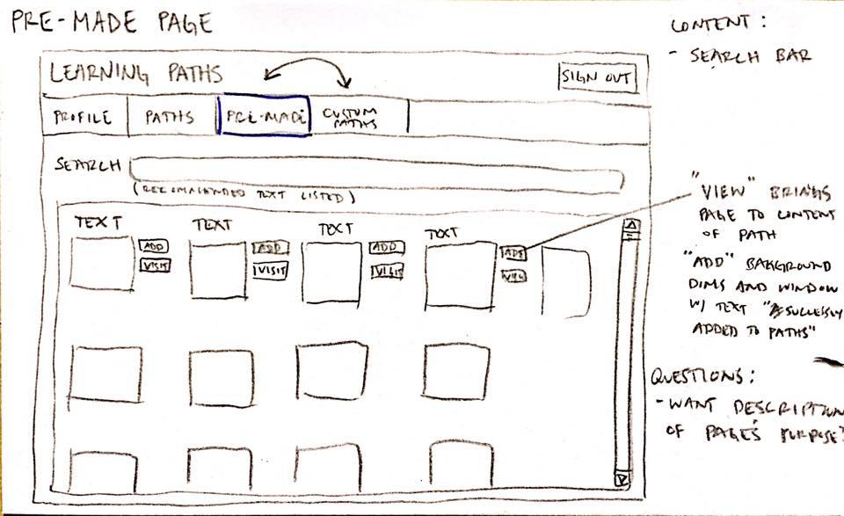

This is the login screen for the Learning Paths page. It is the page that you would get to if you clicked on the Learning Paths link on the main ShowbizU website. The login screen has a button to click on if you want to sign in using Facebook and a button if you want to sign in with email. If the Facebook sign in button is clicked, a separate window will pop up telling the user information “ShowbizU will receive the following info: Your public profil and email address” and underneath would be a “edit info you provide” link as well. Then the window waits for the user to either click the “cancel” or “okay” button. For the When the sign in with email button is clicked, then the email and password logins pop up on the page, and the “sign in” button waits to be clicked. Underneath is a “back” link that will go back to the first Learning Paths page view. Underneath is a link that will be underlined if the mouse pointer is hovering over it. If clicked on, then the link will send you to a different page that will have the user fill out personal information. This page has the user fill out their name, email, password, password confirmation, and whether or not they agree to the terms of use.

Once logged in, the user will be directed to the Profile tab by default. This tab is where the user can set their settings or edit account information.

The Paths tab is the tab that shows what paths the user has in their account right now (the paths they have added).

The Custom Paths tab is where the user(s) will go to create their own path. It has the search function as well as the filters. They create their own path by starting with the “+” symbol which will create and add the path to their collection of paths. They will be able to make up their own title and the description for the path (like the current learning paths does right now). Once they search up content, they can add the content to form their path.

The Pre-made Paths page allows the user to look and browse at the paths already made for them. They can use the search function to find paths that are related to the topic of their interest. They can both view and add the pre-made paths that are available in order to make sure that is something they want to add to their collection of

**Design 3**

The website layout of Learning Paths will have a static sidebar that has links to “My Paths”, “Make Your Path”, “Premade Paths”, and “Recommendations”. On the top will be the title/logo, account access and login/logout button. In the center is where the content will be displayed according to what link was clicked.

This page shows “My Paths”. It will hold all paths created by the user. A user will click on the a path here to be taken to another screen on the following image where more information is given about the contents of the path.

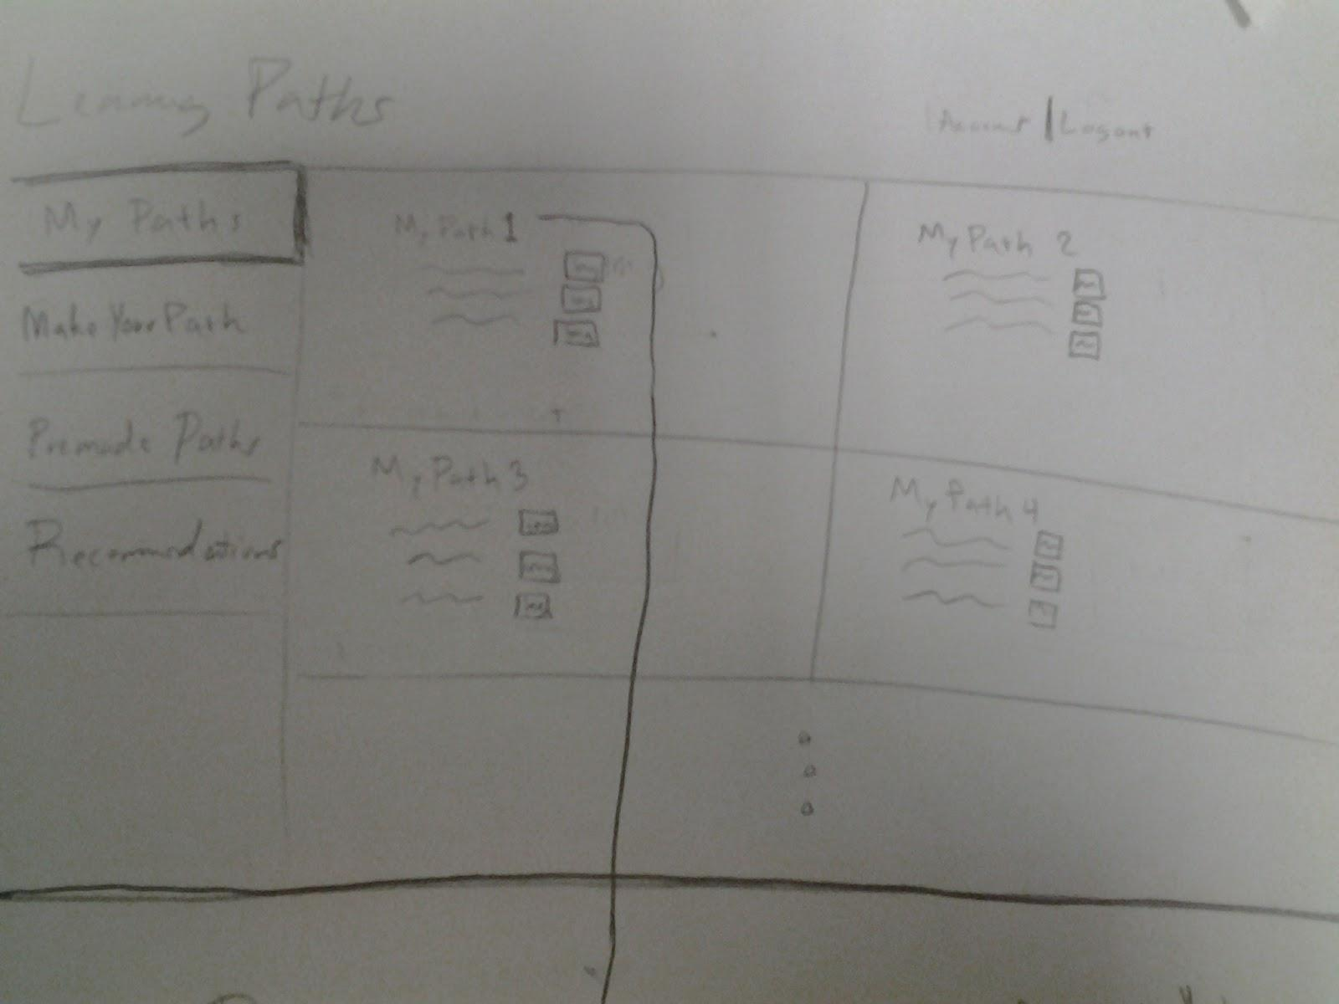

In this image a user has clicked the path and is now able to see the contents they have added to the path. They are able to interact with the content or delete it.

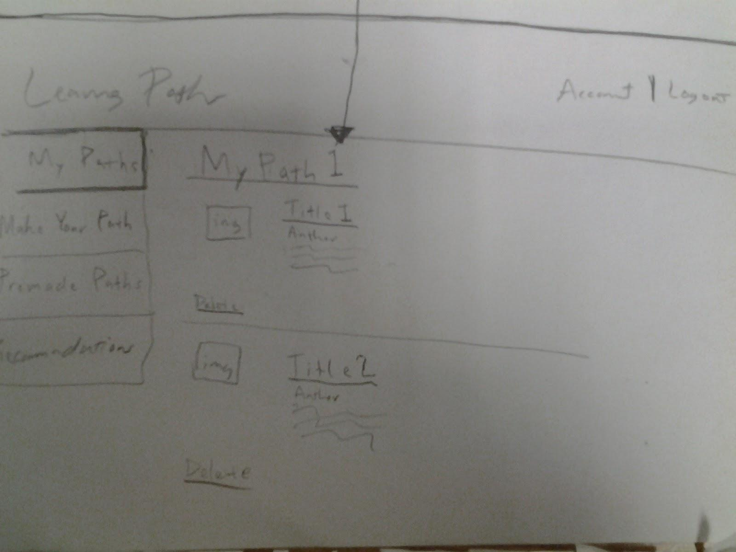

In the next tab called “Make Your Path”, the user will be able to search content and use filters to make their search easier. When the user wants to add content to their paths they will use a drop-down list to choose which path they want to add the content to. After they add it the new content will show up in “My Content”.

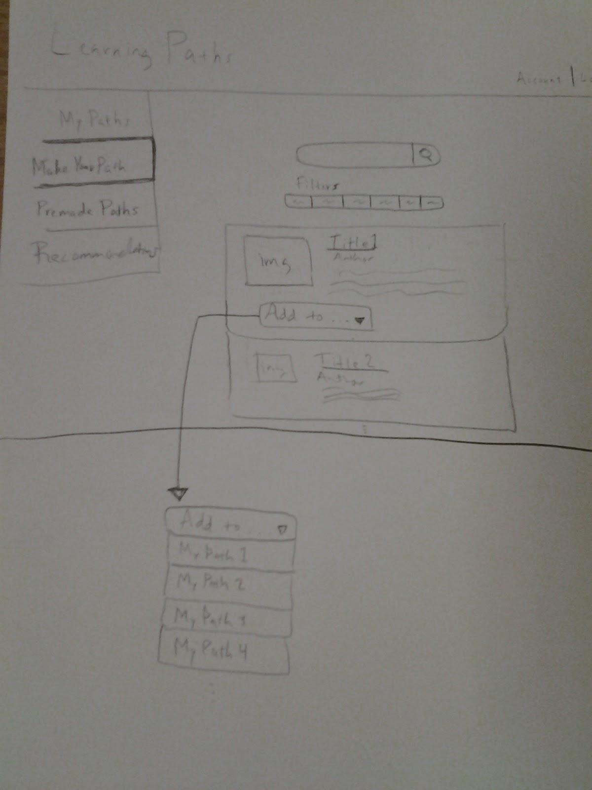

The tab called “Premade Paths” allows user to search for paths with content already added according to type. A user adds “Acting” and they will get an “Acting” path added to “My Paths”. The “Acting” path will have content already added in.

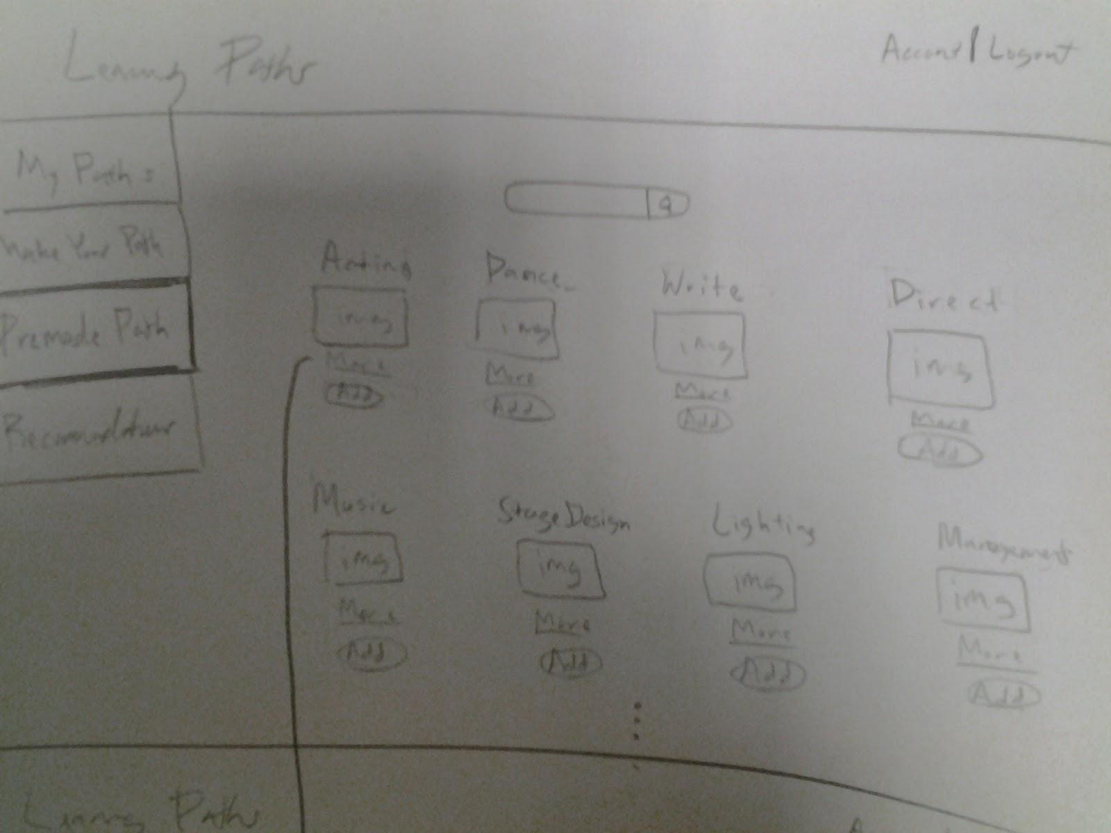

If a user clicks “More”, they will be taken to a new page where all the content of the pre-made path will be displayed.

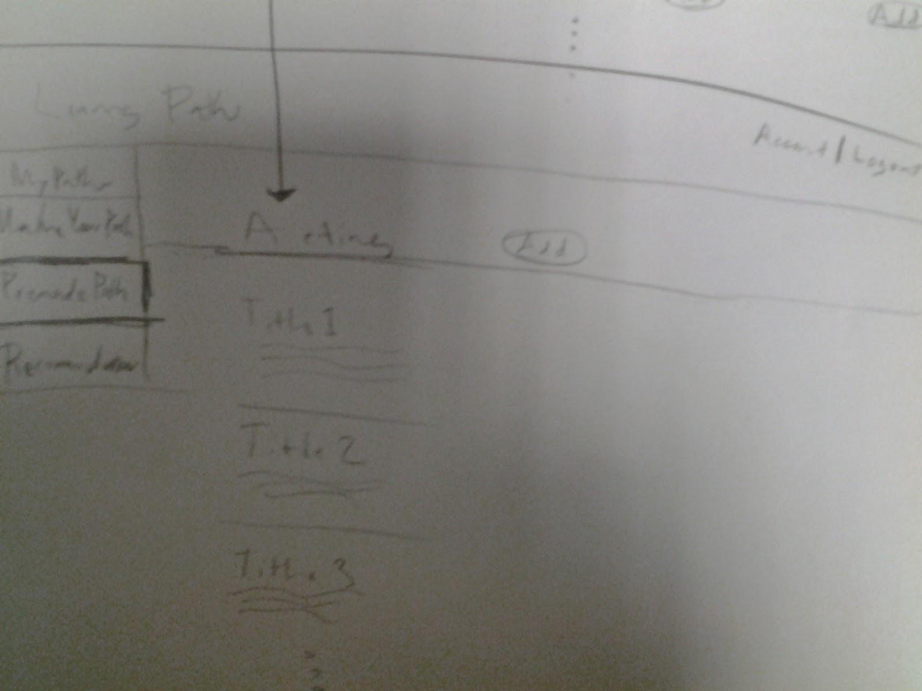

The last tab “Recommendations looks a lot like the Netflix interface where it states why they are recommending you something and then displaying it. You would be able to add pre-made paths or just content to custom paths.

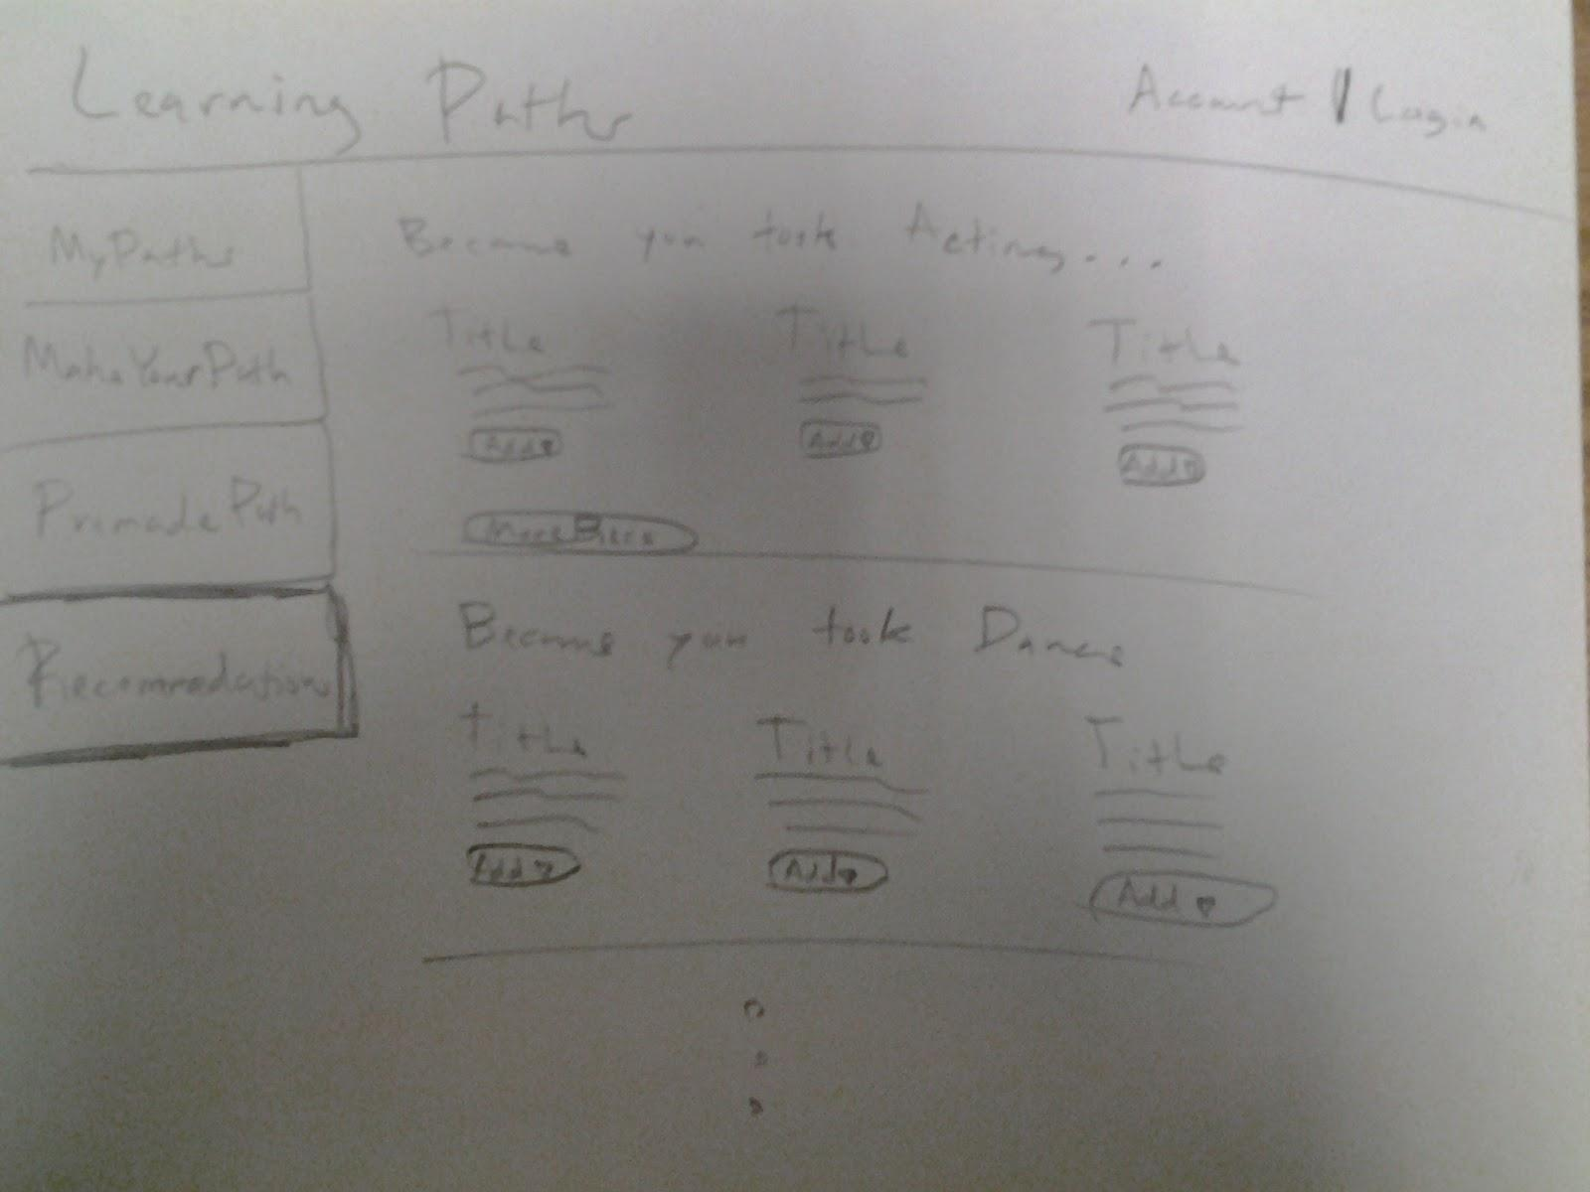

# Competitive Analysis

# ***Netflix***

Netflix is a popular online video streaming website. It relies on a powerful search and recommendation engine, which takes a user’s history of watched shows to suggest new shows. What makes Netflix unique is its ability to recommend shows based on specific previously watched shows, not just a user’s overall collection of watched shows. For example, if Netflix sees that a user has watched numerous episodes of the show *Bones*, it will display a category called “Because you watched Bones”, which has shows and movies similar to *Bones*. The site also tracks overall usage by all its users and generates lists for “Most Popular” and “New Releases”, as well as more categorized lists such as “Dramas” and “Action & Adventure”. Essentially, Netflix creates a persona for the user based on what it thinks the user enjoys. This makes the viewing experience simpler for the user, with less clicks and complicated searches needed.

***YouTube***

YouTube is a video-sharing service that has features similar to ShowbizU’s Learning Paths concept. With over 100 hours of video uploaded to YouTube every single minute, the website has truly become synonymous with the word “videos”. With such a large collection of videos, YouTube boasts an impressive search and recommendation engine, like Netflix. Even without a YouTube account, a user can watch public videos. In each of these videos, there is a given list of recommended videos. It is easy to see how a user can spend hours and hours on YouTube. YouTube tracks a user’s watch history, even if the user does not have an account, and displays a list of recommended videos on its homepage. Like Netflix, it also displays other lists, such as Popular Right Now and Popular Music Videos. When signed in, a user can see even more recommended categories. YouTube will recommend entire channels based on watch history. Similar to Learning Paths in ShowbizU, a YouTube user can create playlists and add as many videos to the playlists as desired. Furthermore, a user can access existing playlists created by others.

***Udacity***

Udacity is an educational organization providing courses in a MOOC format. Founded in 2011 by Sebastian Thrun, David Stavens, and Mike Sokolsky, the website has 1.6 million users and offers 12 full courses and 26 free courseware. Udacity mainly focuses on teaching computer science in Python, as courses consist of video lectures, quizzes, and homework. At the end of the course, users receive certificates of completion, signed by the creator of the course. While users must pay to take the courses and receive certificates, free courseware is also available for those who prefer Just-in-time learning. The site itself was made using the Google App Engine, MongoDB, AWS, AngularJS, and Bootstrap, among other tools. The forum section of the site is well categorized by topic, like “Introduction to Computer Science” and “Software Debugging”. The only concern with this structure is that, because the courseware is mainly about computer science in general, there may be questions in a specific topic that are applicable to other topics as well. Thus, a user may potentially find it difficult to look for questions if they are looking in the wrong topic. Users of Udacity are able to attend Meetups with other users, building the community aspect. These Meetups are created by Udacity students and are used to network and share ideas. Another part of the Udacity community is the blog where users can see new course postings and small tips. Users can also like the Udacity Facebook page to get updates and see who else is using the educational site. While the current site does not have job postings, Udacity will eventually roll out a feature that allows students to pay for taking a course final, in which the certificate they receive for passing will include credential that is recognized by employers.

# Mood Boards

Create three to five casual representations to convey photography style, color palette, typography, patterns, and the overall look and feel of the product.